Day 16
Task 2
1.Open Snowflake Snowsight and create a worksheet.
2.Create warehouse RETAIL_WH.
3.Create database RETAIL_DB.
4.Create schema RAW.
5.Create CUSTOMERS table.
6.Create ORDERS table.

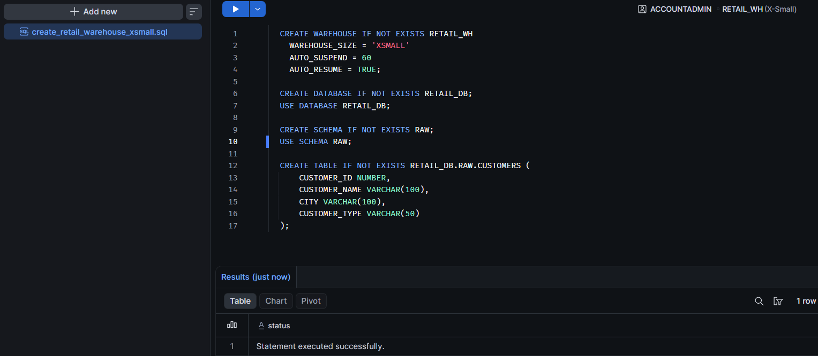
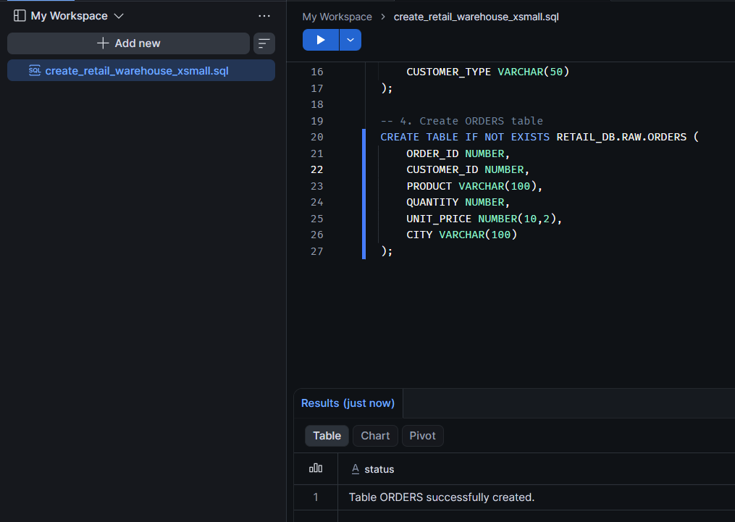
7.Check warehouse and tables

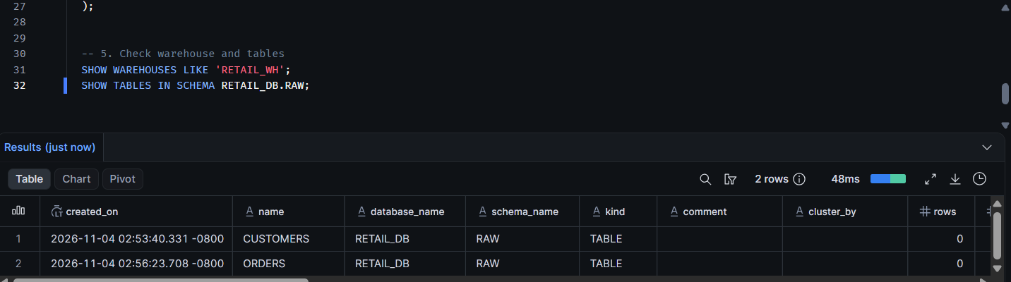

8. Upload the customers.csv file
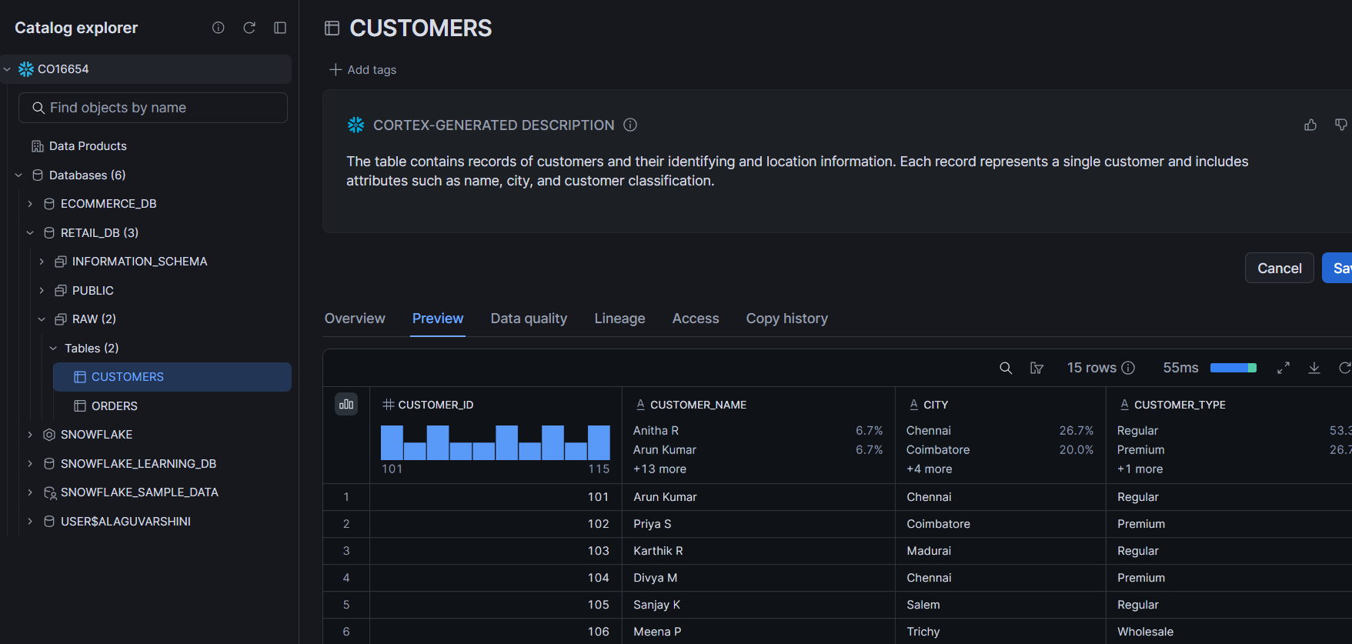

9. Upload the orders.csv files
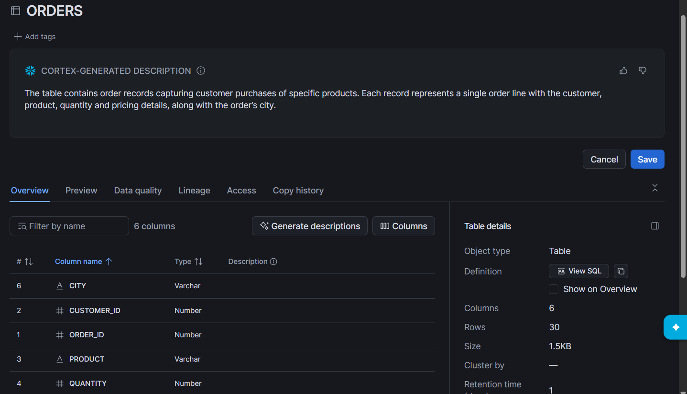

10. Create a file format
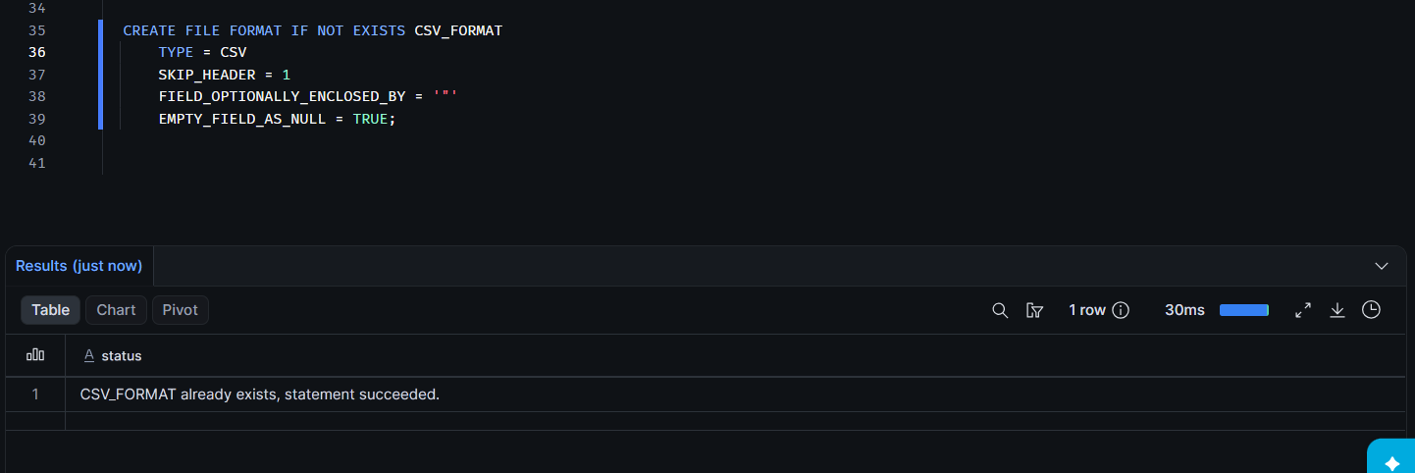
11. Create a stage and Verify the stage
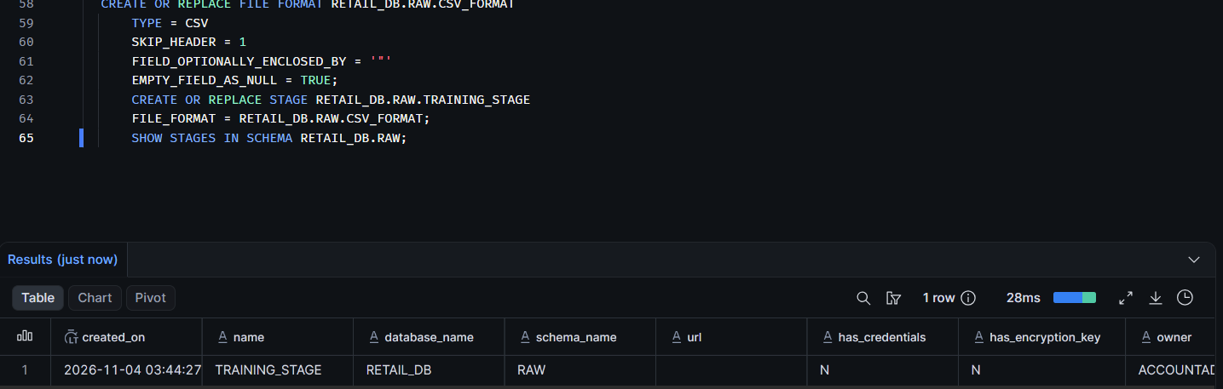
12.Load each staged CSV into its matching table for customers
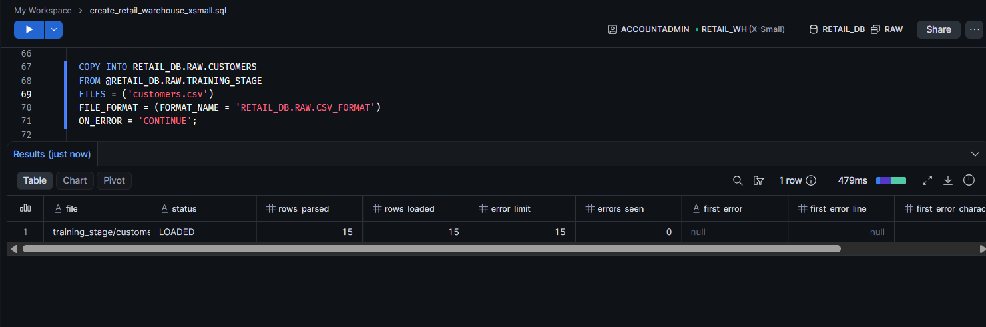

13. Load each staged CSV into its matching table for orders

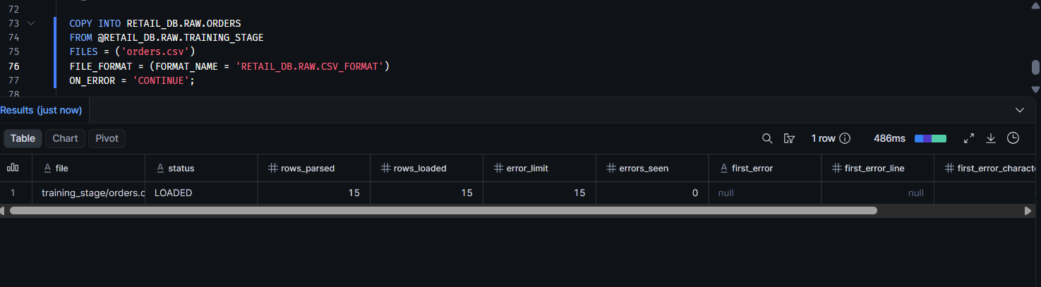

14. Displays all records from your CUSTOMERS table in Snowflake.
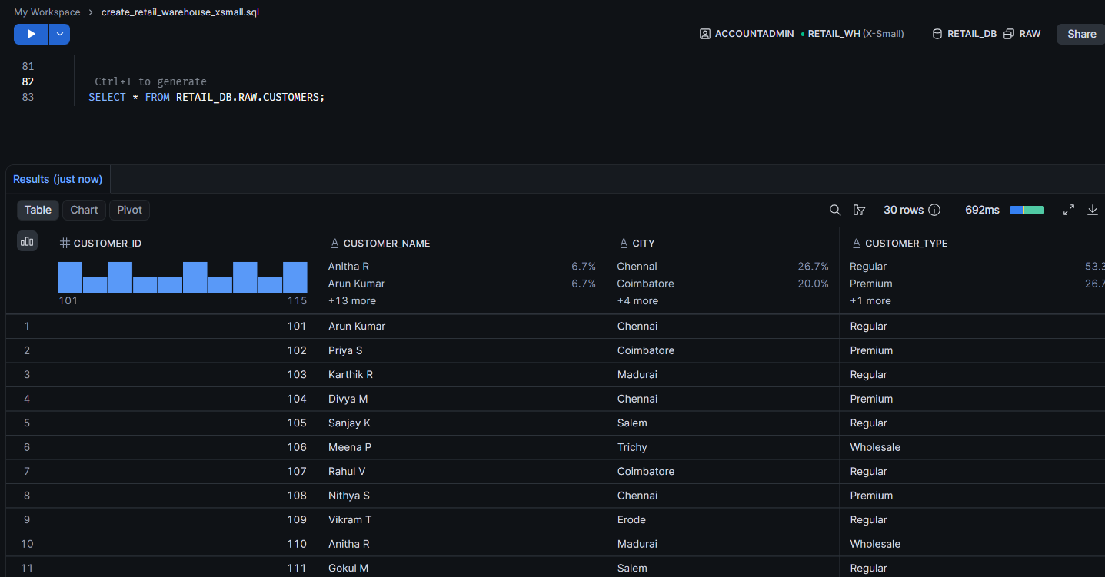
15. displays all records from your ORDERS table in Snowflake.
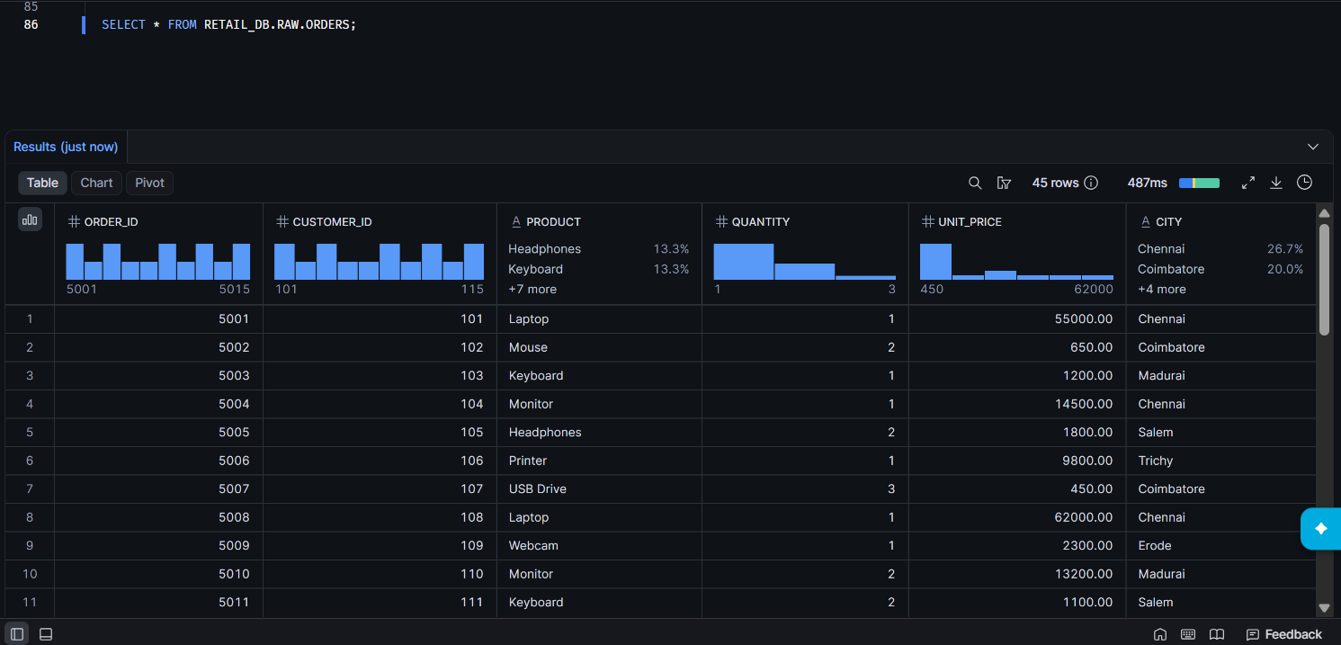

16. Analytical Query
1.16 Display all customers
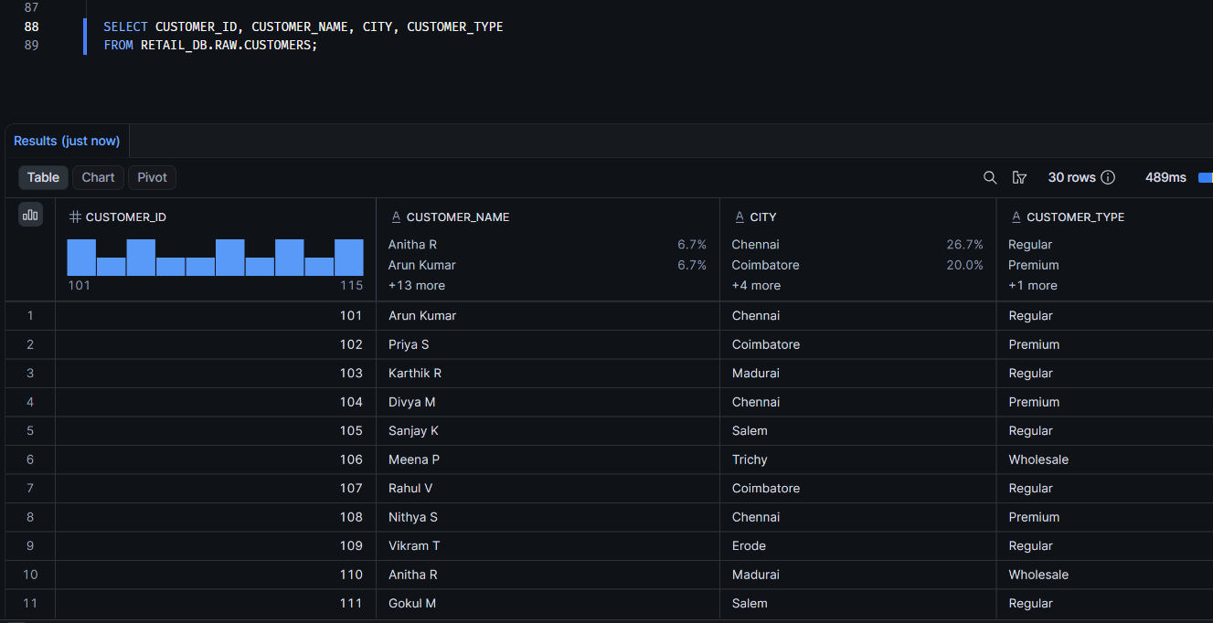

2.16 Display all orders
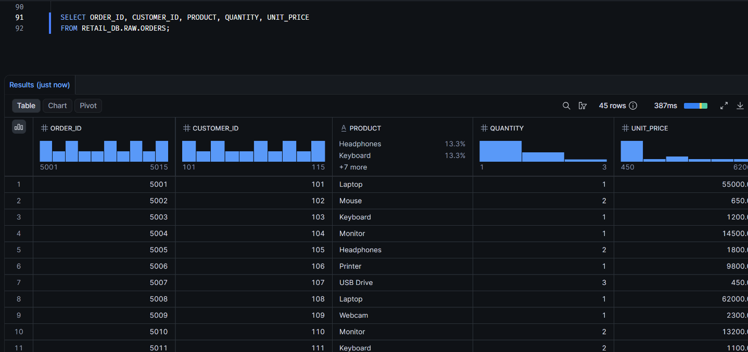

3.16 Filter all orders city wise
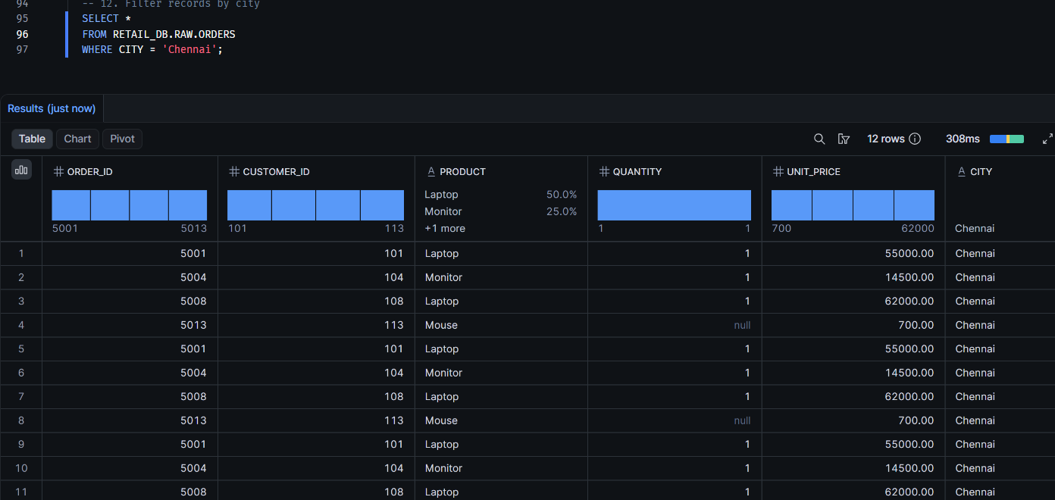

4.16 Calculate total sales
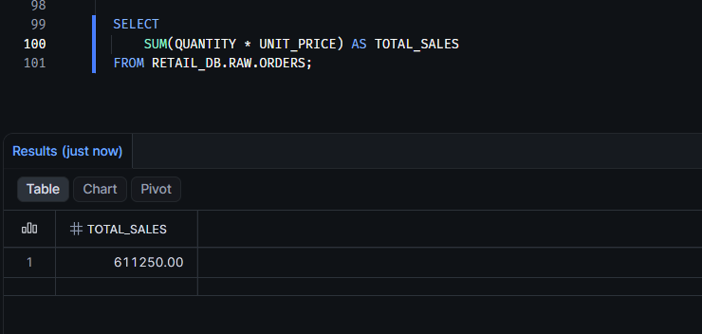

5.16 Product wise sales
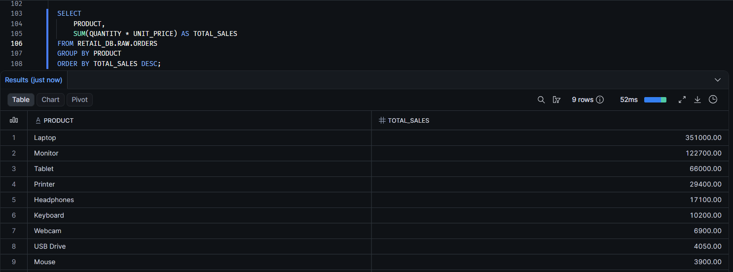

6.16. INNER JOIN: orders with matching customer details
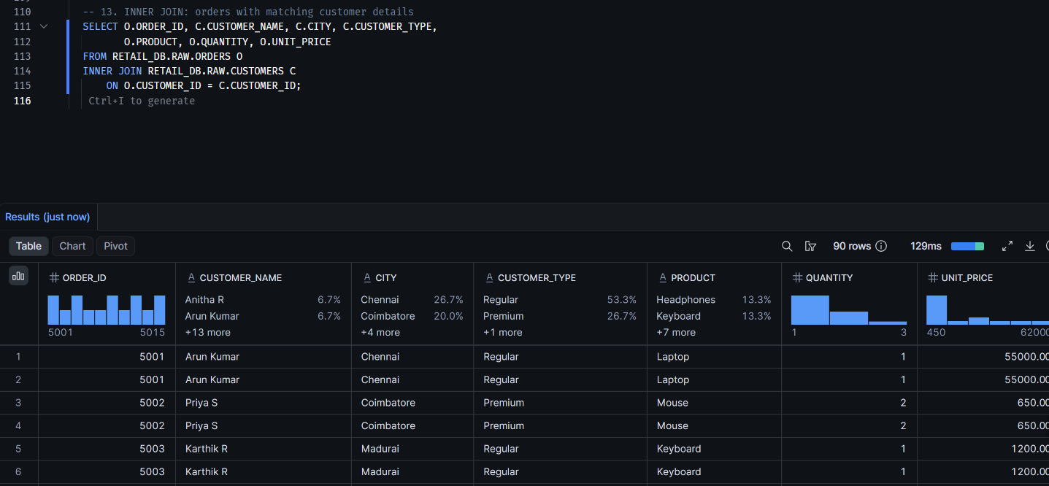

7.16. Find total sales by customer type.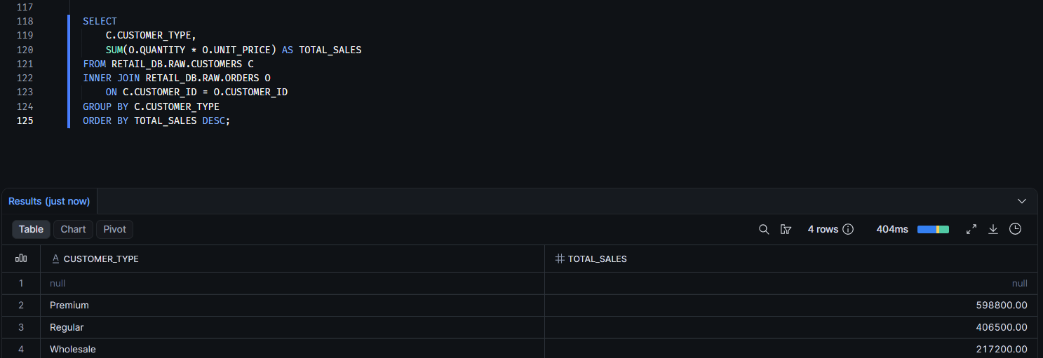

17. Data cleaning and transformation (ETL) in Snowflake.
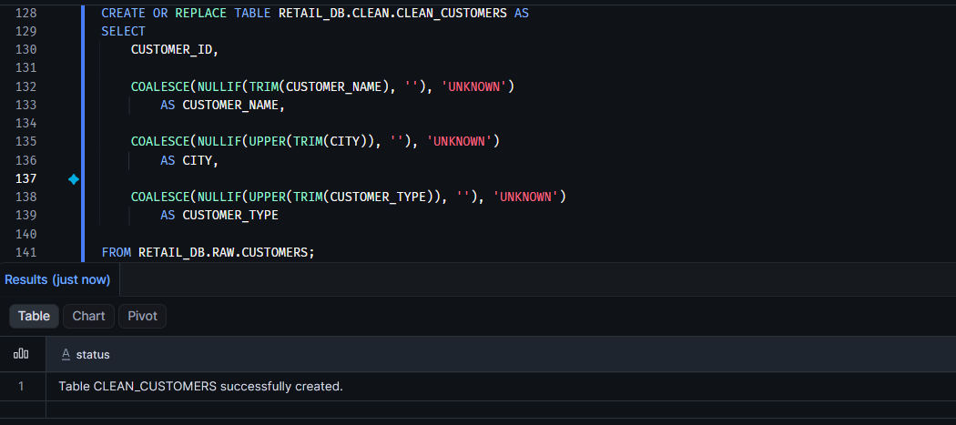

18. Drop all tables, stage, file format and then the database.


